Solution Architecture Design
Container, deployment, integration and security architecture for the self-hosted CERA platform
ARCHITECTURE DECISION Use a modular monolith / small-service architecture on one production server at launch: Next.js + Payload for the public web/content layer, Vendure server + worker for commerce, PostgreSQL for transactional data, Redis/Valkey for jobs/cache, Authentik for protected staff access, GlitchTip for monitoring, and Cloudflare R2 for object storage.

1. Container architecture
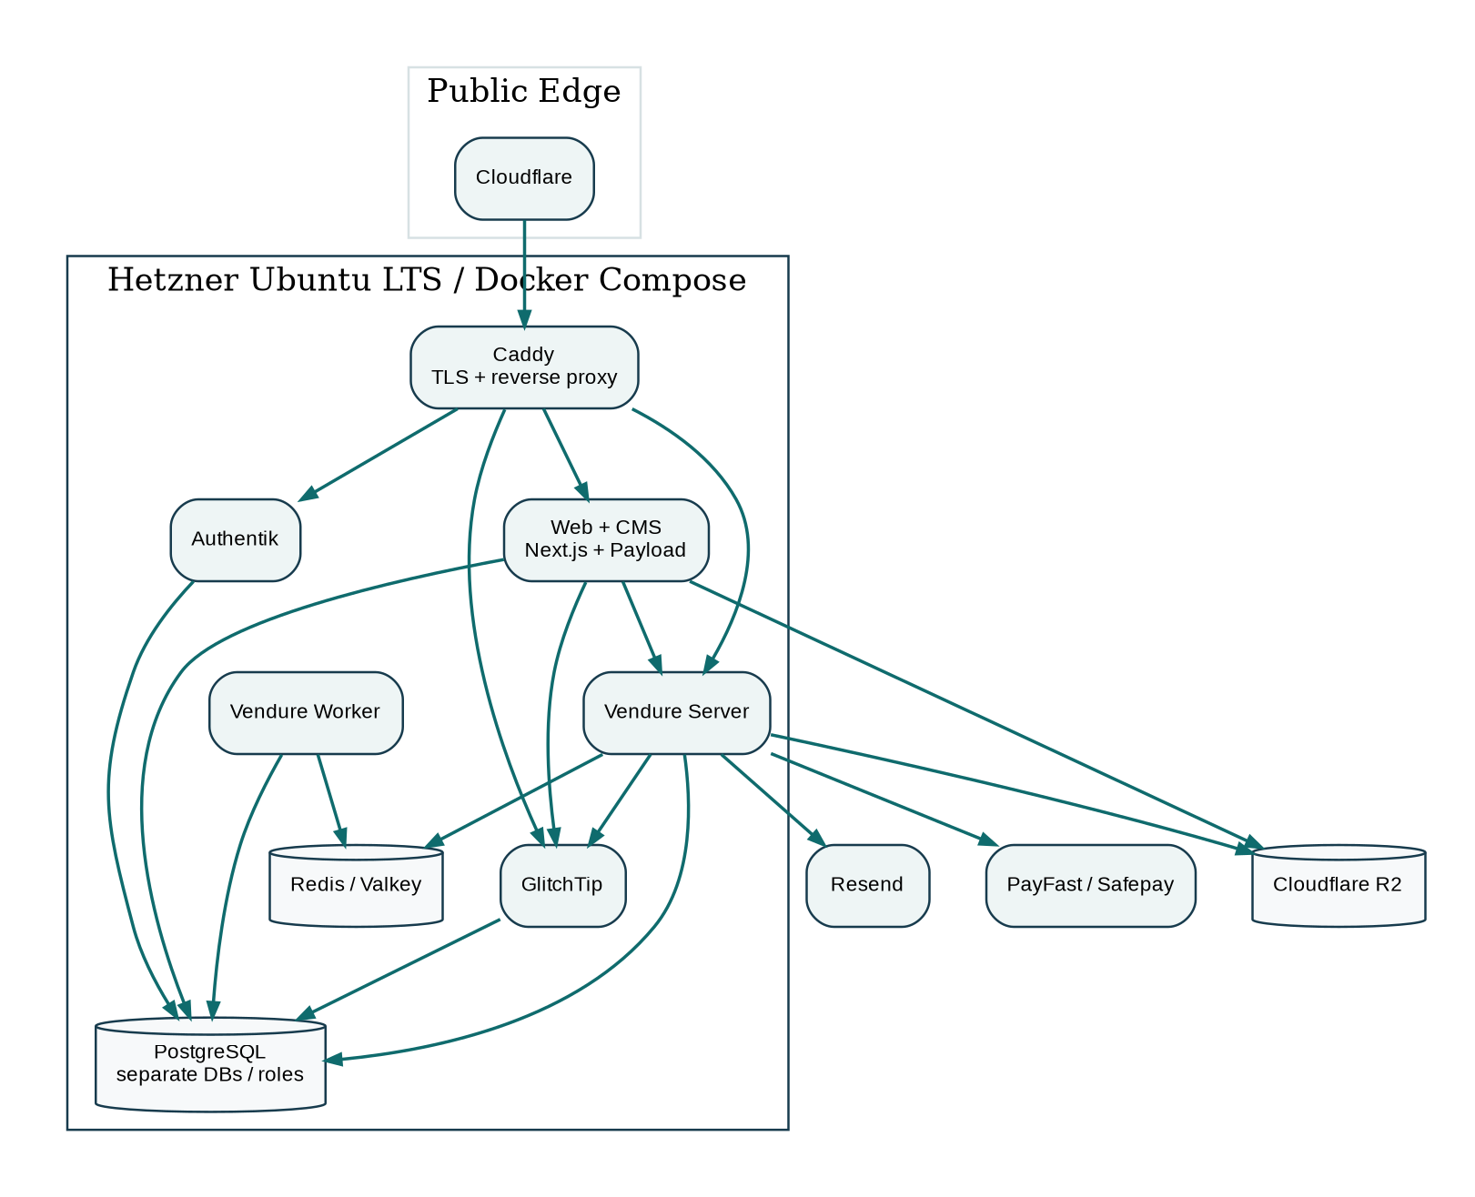
Figure 1. Recommended application/container topology

2. Public routing and hostnames
Hostname / path | Purpose | Exposure
ceramed.org | Canonical public website, shop, services and blog. | Public via Cloudflare
www.ceramed.org | Permanent redirect to canonical hostname. | Public
admin.ceramed.org | Protected staff entry to commerce/content tools. | Authentik-protected
auth.ceramed.org | Authentik login and MFA. | Public login, hardened
errors.ceramed.org | GlitchTip operations UI. | Staff only / protected
API endpoints | Vendure GraphQL endpoints behind the application/edge rules. | Only required endpoints public

3. Trust boundaries
- Edge boundary: Cloudflare terminates public traffic controls and forwards only expected web traffic to Caddy.
- Host boundary: Hetzner firewall exposes only required ports; databases and Redis are not exposed publicly.
- Admin boundary: Authentik provides an outer access gate for staff tools; Vendure/Payload still enforce their own roles.
- Payment boundary: card/payment credentials stay with the payment provider; CERA stores only references/status required for orders.
- Object-storage boundary: public media can be served through controlled URLs; private objects use restricted access/presigned links.

4. Database isolation
- One PostgreSQL service may host multiple logical databases at launch, but Vendure, Payload, Authentik and GlitchTip receive separate databases and least-privilege database users.
- No application receives unrestricted access to another application's tables.
- Database connections stay on the internal Docker network; external database ports remain closed.

5. Availability and scale path
Stage | Trigger | Architecture change
Launch | Normal initial ecommerce/content traffic. | Single 16 GB host; Docker Compose; Cloudflare edge; R2 external storage; automated backups.
Scale 1 | Sustained RAM/CPU pressure or heavy content/commerce jobs. | Resize host or move GlitchTip/AuthentiK to a small operations VM.
Scale 2 | Database contention, large order volume or higher availability need. | Separate PostgreSQL to private/managed database; isolate worker/cache.
Scale 3 | High campaign traffic / business-critical SLA. | Multiple web/API nodes behind load balancer, dedicated database, external queue/cache and formal DR.

6. Recommended launch compute
Recommended production host: Hetzner CX43 class in EU Central: 8 vCPU, 16 GB RAM, 160 GB NVMe, plus Primary IPv4 and automated backups. The 16 GB recommendation is intentional because the chosen stack self-hosts commerce, CMS, identity and observability together.
Lean alternative: CX33 (4 vCPU / 8 GB / 80 GB) can be used only if actual memory measurements remain comfortable; it is not the preferred production baseline for the full self-hosted stack.

7. Network and secrets controls
- Cloudflare proxy enabled for public web hosts.
- Hetzner firewall permits SSH only from controlled sources where practical, and HTTP/HTTPS only to the reverse proxy.
- Secrets stored in protected environment files/secret store and never committed to Git.
- Separate production and staging credentials; rotate credentials during handover when appropriate.
- Webhook signature validation for payment providers and any future courier integrations.

8. Architecture principles
- Prefer open-source/self-hosted components when they reduce recurring cost without creating disproportionate operational risk.
- Use managed external services where deliverability, payments, or durable object storage benefit from specialist infrastructure.
- Avoid microservices until measured load or team boundaries justify them.
- Design integrations behind adapters so PayFast/Safepay, email or storage providers can be replaced without rewriting the whole application.

